EXISTING METHODS ON SAFETY ISSUES DUE TO MANUAL INSPECTION IN INDUSTRIES

I.Visual inspection:
Description: Visual inspection is a manual quality control process where trained inspectors assess products, components, or assemblies for defects and compliance with specifications. This method relies on the inspector's expertise and keen observation skills to identify flaws that may not be detected through automated processes.
Working Principles:
1. Visual Acuity: Ability to detect and recognize defects or irregularities
2. Lighting: Adequate illumination to enhance visibility
3. Magnification: Use of optical instruments to enlarge images
4. Angle of View: Inspection from multiple angles to detect hidden defects
5. Inspection Criteria: Clear standards and specifications for evaluation
Inspection process:
Observe surface, structure, or component. Record observations, notes, images. Take precise measurements (dimensions, thickness).Compare to specifications, standards, or reference images. Inspect critical areas (welds, joints, connections). Check for defects (cracks, corrosion, damage). Verify functionality (movement, operation). Inspect safety features (guards, warnings).Document inspection route (sequence, locations).Complete inspection checklist.
Key Features of Visual Inspection
- Expertise-Based: Relies on the trained skills and judgment of inspectors.
- Flexibility: Applicable across various industries and products.
- Techniques Used: Involves close-up examinations, surface checks, and dimensional measurements.
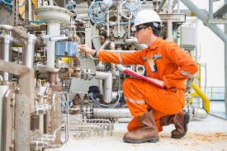
II.Robotics crawlers:
Description: Robotic crawlers are versatile, autonomous or remotely controlled robots designed to navigate through confined, hazardous, or hard-to-reach areas. They are equipped with sensors, cameras, and sometimes tools for performing inspections, monitoring, and even minor maintenance tasks.
Working Principles

1. Sensors and Navigation: Utilize sensors (ultrasonic, lidar, cameras) for navigation and mapping.
2. Actuation and Propulsion: Employ tracks, wheels, or magnetic adhesion for movement.
3. Control Systems: Advanced algorithms and software control crawler movements and actions.
4. Communication: Wireless or wired communication enables data transmission and remote control.
Inspection Process:
The inspection process using robotic crawlers in industries involves deploying these advanced machines to navigate challenging environments like pipelines and tanks. Equipped with sensors and cameras, the crawlers capture real-time data and images while analyzing them for defects such as wear or corrosion. Immediate alerts are generated for any detected issues, and findings are documented for compliance and traceability. This method enhances safety by reducing the need for human intervention in hazardous areas, while improving efficiency and accuracy in monitoring critical infrastructure. Regular maintenance of the crawlers ensures their reliability for future inspections.

Key Features and Benefits
1.Mobility and Flexibility
Compact Design: Designed to navigate narrow or obstructed spaces, such as pipelines, tunnels, and tanks.
Adaptable Movement: Capable of climbing, crawling, or rolling, depending on the design, allowing access to various terrains and obstacles.
2.Safety and Efficiency
Hazardous Environments: Ideal for inspecting dangerous or toxic environments without exposing human workers to risks.
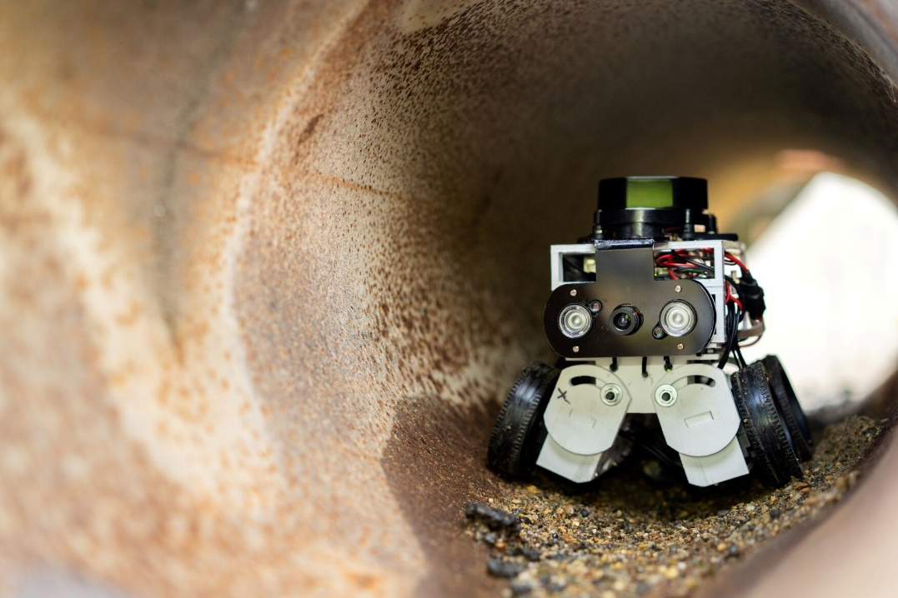

III. Camera-Based Vision Systems
Description: Camera-based vision systems use high-resolution cameras and sophisticated image processing software to capture and analyse visual data. These systems can detect defects, measure dimensions, and verify quality in real-time.
Working Principles:

1. Image Capture: High-resolution cameras capture images or videos of the inspection area.
2. Image Processing: Advanced algorithms process images to detect defects, anomalies, or hazards.
3. Object Detection: Machine learning-based algorithms detect specific objects or features.
4. Pattern Recognition: Systems recognize patterns, such as cracks, corrosion, or wear.
5. Classification: Systems classify defects or anomalies based on severity or type.
6. Alert and Reporting: Systems generate alerts and reports for maintenance or repair.

Inspection Process:
Camera-based vision systems in industrial inspection involve strategically placed cameras that capture high-resolution images of products as they move along the production line. These images are analyzed in real-time using advanced algorithms to detect defects such as scratches and misalignments. The system automatically decides whether to accept or reject items based on predefined quality criteria, generating alerts for any issues. This process not only improves product quality and efficiency but also facilitates thorough documentation and compliance, ensuring consistent performance through regular maintenance and recalibration of the systems.

Key Features
- High Resolution: Provides detailed imaging for precise defect detection and quality control.
- Real-Time Processing: Capable of processing images quickly for immediate feedback and decision-making.
- Versatility: Can be used for various applications, including inspection, measurement, and identification in different industries.

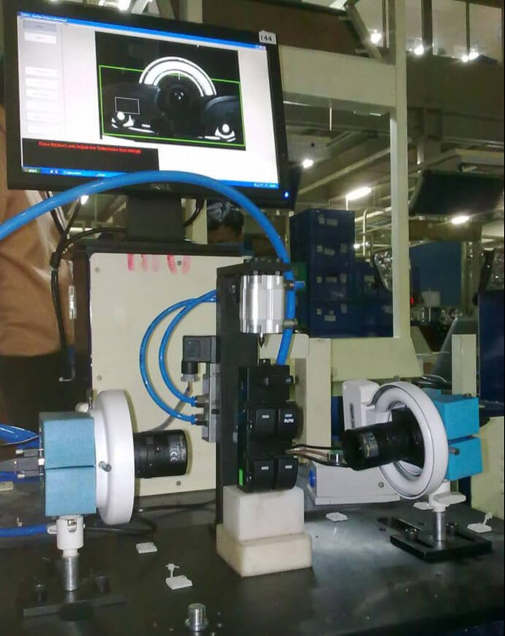

IV. Sensor-Based Monitoring
Description: Involves using a range of sensors to continuously collect and analyse data from equipment, machinery, or environmental conditions during manual inspections. These sensors provide real-time insights that help identify issues before they escalate, enhance safety, and improve overall inspection processes.
Working Principles:
1. Sensor Deployment: Install sensors in strategic locations to monitor parameters.
2. Data Collection: Sensors collect data on temperature, pressure, vibration, and more.
3. Data Transmission: Sensors transmit data to central monitoring systems.
4. Data Analysis: Advanced algorithms analyze data to detect anomalies.
5. Alert and Reporting: Systems generate alerts and reports for maintenance or repair.
Inspection Process:
The sensor-based monitoring inspection process in industries involves strategically installing various sensors to continuously track key parameters like temperature, pressure, and vibration. These sensors collect real-time data, which is transmitted to a centralized system for analysis. When data exceeds predefined thresholds, automated alerts are triggered, enabling immediate responses to potential issues. Collected data is logged for historical analysis, aiding in trend identification and predictive maintenance. Regular calibration ensures the sensors' accuracy and reliability, ultimately enhancing operational safety and efficiency while helping to prevent equipment failures.

Key Features
- Real-Time Data Collection: Continuously gathers data from the environment or equipment, providing immediate insights.
- Variety of Sensors: Utilizes multiple types of sensors (e.g., temperature, pressure, humidity, vibration) for comprehensive monitoring.
- Remote Access: Allows users to monitor systems remotely through connected devices, enhancing convenience and flexibility.

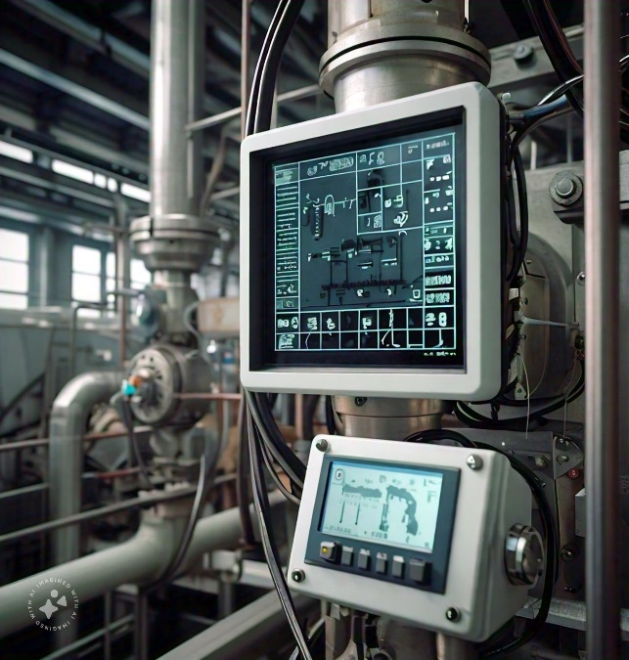

V. IoT Sensors for Safety in Industries:
Description
IoT (Internet of Things) sensors are advanced technological devices embedded with capabilities to monitor, collect, and transmit data regarding various parameters critical to safety in industrial environments. They address the limitations of manual inspections by providing continuous, real-time data and automation that enhance safety, efficiency, and compliance.
Working Principles:

1. Sensor Deployment: Install IoT sensors in strategic locations.
2. Data Collection: Sensors collect data on temperature, pressure, vibration, and more.
3. Data Transmission: Sensors transmit data to cloud or local servers.
4. Data Analysis: Advanced algorithms analyze data to detect anomalies.
5. Alert and Reporting: Systems generate alerts and reports for maintenance or repair
Inspection Process:
The inspection process using IoT sensors for safety in industries involves deploying interconnected sensors to monitor critical parameters like gas levels, temperature, and equipment performance in real-time. These sensors continuously collect data and transmit it to a central system for analysis. When safety thresholds are exceeded, automated alerts are triggered, enabling quick responses to potential hazards. The data is also logged for compliance reporting and trend analysis, which helps identify areas for improvement. Regular maintenance and calibration ensure the sensors' accuracy, ultimately enhancing workplace safety and promoting proactive risk management.

Key features:
- Real-Time Monitoring: Continuously tracks environmental conditions (e.g., temperature, humidity, gas levels) to ensure safe operating conditions.
- Wireless Connectivity: Utilizes wireless technologies (e.g., Wi-Fi, LoRa, Zigbee) for easy installation and flexibility in data transmission.
- Automated Alerts and Notifications: Sends immediate alerts to personnel when safety thresholds are breached, enabling quick response actions.

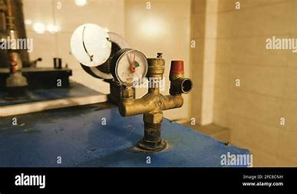
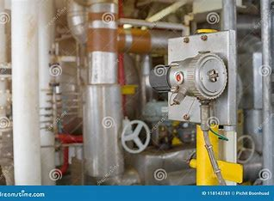

Limitations of Existing Methods:
1. Human error
2. Time-consuming and labor-intensive
3. Limited coverage area
4. High costs
5. Safety risks to inspectors
6. Inaccurate or incomplete data
7. Difficulty in accessing confined spaces

